Lab-4

1. Create art and craft photo album using bootstrap.

Html File :-

<!DOCTYPE *html*>

<html *lang*="en">

  <head>

    <meta *charset*="UTF-8" />

    <meta *name*="viewport" *content*="width=device-width, initial-scale=1.0" />

    <title>Art and Craft Photo Album</title>

    <link

*rel*="stylesheet"

*href*="https://stackpath.bootstrapcdn.com/bootstrap/4.5.2/css/bootstrap.min.css"

    />

    <link

*rel*="stylesheet"

*href*="https://cdnjs.cloudflare.com/ajax/libs/font-awesome/5.15.3/css/all.min.css"

    />

    <style>

      body {

        background-color: rgb(159, 137, 172);

      }

*.album* {

        padding: 30px 0;

      }

*.card-img-top* {

        height: 250px;

        object-fit: cover;

        transition: transform 0.4s ease;

      }

*.card-img-top:hover* {

        transform: scale(1.03);

      }

*.card* {

        background-color: rgb(12, 2, 16);

        transition: transform 0.6s ease;

      }

*.card:hover* {

        box-shadow: 0 8px 16px white;

        transform: scale(1.1);

      }

*.card-body* {

        text-align: center;

      }

*.card-title* {

        font-size: 1.5rem;

        font-family: "Playfair Display", serif;

      }

*.card-text* {

        color: rgb(159, 137, 172);

        font-family: serif;

      }

*.fancy-text* {

        font-family: "Brush Script MT", cursive;

        font-size: 45px;

        color: rgb(12, 2, 16);

      }

      i {

        transition: transform 0.5s ease;

      }

      i*:hover* {

        color: rgb(131, 9, 25) !important;

        transform: scale(1.5);

      }

    </style>

  </head>

  <body *style*="background-color: rgb(159, 137, 172)">

    <div *class*="album py-5">

      <div *class*="container">

        <h1 *class*="text-center mb-5 fancy-text">Art and Craft Photo Album</h1>

        <div *class*="row">

          <div *class*="col-md-4 rounded-lg px-4">

            <div *class*="card mb-0 shadow-sm rounded-lg">

              <img

*src*="image/Art_Album/art1.jpg"

*class*="card-img-top p-4 rounded-lg"

*alt*="Art and Craft"

              />

              <div *class*="d-flex justify-content-between align-items-center">

                <i *class*="fas fa-heart ml-4" *style*="color: red"></i>

                <small *class*="text-muted mr-4">9/10</small>

              </div>

              <div *class*="card-body pt-0 pb-4 mb-1">

                <h5 *class*="card-title text-white">Tech Girl</h5>

                <p *class*="card-text">

                  An aesthetic photo of a tech-savvy girl surrounded by purple

                  hues, showcasing the blend of technology and style.

                </p>

              </div>

            </div>

          </div>

          <div *class*="col-md-4 rounded-lg px-4">

            <div *class*="card mb-0 shadow-sm rounded-lg">

              <img

*src*="image/Art_Album/art2.jpg"

*class*="card-img-top p-4 rounded-lg"

*alt*="Art and Craft"

              />

              <div *class*="d-flex justify-content-between align-items-center">

                <i *class*="fas fa-heart ml-4" *style*="color: red"></i>

                <small *class*="text-muted mr-4">9/10</small>

              </div>

              <div *class*="card-body pt-0 pb-4 mb-1">

                <h5 *class*="card-title text-white">Nature</h5>

                <p *class*="card-text">

                  A tranquil nature scene bathed in serene purple tones. The

                  image captures the peaceful essence of natural beauty.

                </p>

              </div>

            </div>

          </div>

          <div *class*="col-md-4 rounded-lg px-4">

            <div *class*="card mb-0 shadow-sm rounded-lg">

              <img

*src*="image/Art_Album/art3.jpg"

*class*="card-img-top p-4 rounded-lg"

*alt*="Art and Craft"

              />

              <div *class*="d-flex justify-content-between align-items-center">

                <i *class*="fas fa-heart ml-4" *style*="color: red"></i>

                <small *class*="text-muted mr-4">9/10</small>

              </div>

              <div *class*="card-body pt-0 pb-4 mb-1">

                <h5 *class*="card-title text-white">Heart Lights</h5>

                <p *class*="card-text">

                  A building adorned with lights forming a heart shape, glowing

                  in a mesmerizing purple hue. The image radiates love.

                </p>

              </div>

            </div>

          </div>

        </div>

        <div *class*="row mt-5">

          <div *class*="col-md-4 rounded-lg px-4">

            <div *class*="card mb-0 shadow-sm rounded-lg">

              <img

*src*="image/Art_Album/art4.jpg"

*class*="card-img-top p-4 rounded-lg"

*alt*="Art and Craft"

              />

              <div *class*="d-flex justify-content-between align-items-center">

                <i *class*="fas fa-heart ml-4" *style*="color: red"></i>

                <small *class*="text-muted mr-4">9/10</small>

              </div>

              <div *class*="card-body pt-0 pb-4 mb-1">

                <h5 *class*="card-title text-white">Notes & Laptop</h5>

                <p *class*="card-text">

                  A stylish setup featuring notes and a laptop, all set in a

                  soothing purple ambiance. Perfect for creative and tech

                  enthusiasts.

                </p>

              </div>

            </div>

          </div>

          <div *class*="col-md-4 rounded-lg px-4">

            <div *class*="card mb-0 shadow-sm rounded-lg">

              <img

*src*="image/Art_Album/art5.jpg"

*class*="card-img-top p-4 rounded-lg"

*alt*="Art and Craft"

              />

              <div *class*="d-flex justify-content-between align-items-center">

                <i *class*="fas fa-heart ml-4" *style*="color: red"></i>

                <small *class*="text-muted mr-4">9/10</small>

              </div>

              <div *class*="card-body pt-0 pb-4 mb-1">

                <h5 *class*="card-title text-white">Foggy Train</h5>

                <p *class*="card-text">

                  A train shrouded in thick fog, making its way through a

                  mysterious purple landscape. The scene evokes a sense of

                  intrigue.

                </p>

              </div>

            </div>

          </div>

          <div *class*="col-md-4 rounded-lg px-4">

            <div *class*="card mb-0 shadow-sm rounded-lg">

              <img

*src*="image/Art_Album/art6.jpg"

*class*="card-img-top p-4 rounded-lg"

*alt*="Art and Craft"

              />

              <div *class*="d-flex justify-content-between align-items-center">

                <i *class*="fas fa-heart ml-4" *style*="color: red"></i>

                <small *class*="text-muted mr-4">9/10</small>

              </div>

              <div *class*="card-body pt-0 pb-4 mb-1">

                <h5 *class*="card-title text-white">Chess</h5>

                <p *class*="card-text">

                  A captivating chessboard set against a dramatic purple

                  backdrop. The pieces seem to come alive in this enchanting

                  scene.

                </p>

              </div>

            </div>

          </div>

        </div>

        <div *class*="row mt-5">

          <div *class*="col-md-4 rounded-lg px-4">

            <div *class*="card mb-0 shadow-sm rounded-lg">

              <img

*src*="image/Art_Album/art7.jpg"

*class*="card-img-top p-4 rounded-lg"

*alt*="Art and Craft"

              />

              <div *class*="d-flex justify-content-between align-items-center">

                <i *class*="fas fa-heart ml-4" *style*="color: red"></i>

                <small *class*="text-muted mr-4">9/10</small>

              </div>

              <div *class*="card-body pt-0 pb-4 mb-1">

                <h5 *class*="card-title text-white">Cats & Moon</h5>

                <p *class*="card-text">

                  Two curious cats gazing at the moon, illuminated by a dreamy

                  purple light. The image captures a magical moment.

                </p>

              </div>

            </div>

          </div>

          <div *class*="col-md-4 rounded-lg px-4">

            <div *class*="card mb-0 shadow-sm rounded-lg">

              <img

*src*="image/Art_Album/art8.jpg"

*class*="card-img-top p-4 rounded-lg"

*alt*="Art and Craft"

              />

              <div *class*="d-flex justify-content-between align-items-center">

                <i *class*="fas fa-heart ml-4" *style*="color: red"></i>

                <small *class*="text-muted mr-4">9/10</small>

              </div>

              <div *class*="card-body pt-0 pb-4 mb-1">

                <h5 *class*="card-title text-white">Heart Hands</h5>

                <p *class*="card-text">

                  A couple’s hands forming a heart shape, illuminated by a soft

                  purple glow. The image symbolizes love and connection.

                </p>

              </div>

            </div>

          </div>

          <div *class*="col-md-4 rounded-lg px-4">

            <div *class*="card mb-0 shadow-sm rounded-lg">

              <img

*src*="image/Art_Album/art9.jpg"

*class*="card-img-top p-4 rounded-lg"

*alt*="Art and Craft"

              />

              <div *class*="d-flex justify-content-between align-items-center">

                <i *class*="fas fa-heart ml-4" *style*="color: red"></i>

                <small *class*="text-muted mr-4">9/10</small>

              </div>

              <div *class*="card-body pt-0 pb-4 mb-1">

                <h5 *class*="card-title text-white">Rose Fire</h5>

                <p *class*="card-text">

                  A dramatic image of a rose being set ablaze against a deep

                  purple backdrop. The intense contrast captures a powerful

                  moment.

                </p>

              </div>

            </div>

          </div>

        </div>

        <div *class*="row mt-5">

          <div *class*="col-md-4 rounded-lg px-4">

            <div *class*="card mb-0 shadow-sm rounded-lg">

              <img

*src*="image/Art_Album/art10.jpg"

*class*="card-img-top p-4 rounded-lg"

*alt*="Art and Craft"

              />

              <div *class*="d-flex justify-content-between align-items-center">

                <i *class*="fas fa-heart ml-4" *style*="color: red"></i>

                <small *class*="text-muted mr-4">9/10</small>

              </div>

              <div *class*="card-body pt-0 pb-4 mb-1">

                <h5 *class*="card-title text-white">Saturn</h5>

                <p *class*="card-text">

                  A mesmerizing view of Saturn surrounded by a purple cosmic

                  haze. The image captures the mystery of our solar system.

                </p>

              </div>

            </div>

          </div>

          <div *class*="col-md-4 rounded-lg px-4">

            <div *class*="card mb-0 shadow-sm rounded-lg">

              <img

*src*="image/Art_Album/art11.jpg"

*class*="card-img-top p-4 rounded-lg"

*alt*="Art and Craft"

              />

              <div *class*="d-flex justify-content-between align-items-center">

                <i *class*="fas fa-heart ml-4" *style*="color: red"></i>

                <small *class*="text-muted mr-4">9/10</small>

              </div>

              <div *class*="card-body pt-0 pb-4 mb-1">

                <h5 *class*="card-title text-white">Heart Eye</h5>

                <p *class*="card-text">

                  An eye with a heart-shaped pupil, set against a soft purple

                  backdrop. The image symbolizes love and vision in a unique

                  way.

                </p>

              </div>

            </div>

          </div>

          <div *class*="col-md-4 rounded-lg px-4">

            <div *class*="card mb-0 shadow-sm rounded-lg">

              <img

*src*="image/Art_Album/art12.jpg"

*class*="card-img-top p-4 rounded-lg"

*alt*="Art and Craft"

              />

              <div *class*="d-flex justify-content-between align-items-center">

                <i *class*="fas fa-heart ml-4" *style*="color: red"></i>

                <small *class*="text-muted mr-4">9/10</small>

              </div>

              <div *class*="card-body pt-0 pb-4 mb-1">

                <h5 *class*="card-title text-white">Butterfly Kisses</h5>

                <p *class*="card-text">

                  An x-ray of a couple’s skulls with butterflies inside, trying

                  to kiss. The surreal image blends love with the beauty.

                </p>

              </div>

            </div>

          </div>

        </div>

        <div *class*="row mt-5">

          <div *class*="col-md-4 rounded-lg px-4">

            <div *class*="card mb-0 shadow-sm rounded-lg">

              <img

*src*="image/Art_Album/art13.jpg"

*class*="card-img-top p-4 rounded-lg"

*alt*="Art and Craft"

              />

              <div *class*="d-flex justify-content-between align-items-center">

                <i *class*="fas fa-heart ml-4" *style*="color: red"></i>

                <small *class*="text-muted mr-4">9/10</small>

              </div>

              <div *class*="card-body pt-0 pb-4 mb-1">

                <h5 *class*="card-title text-white">Candle</h5>

                <p *class*="card-text">

                  A beautifully lit purple candle creating a calm and soothing

                  ambiance, perfect for a relaxing evening.

                </p>

              </div>

            </div>

          </div>

          <div *class*="col-md-4 rounded-lg px-4">

            <div *class*="card mb-0 shadow-sm rounded-lg">

              <img

*src*="image/Art_Album/art14.jpg"

*class*="card-img-top p-4 rounded-lg"

*alt*="Art and Craft"

              />

              <div *class*="d-flex justify-content-between align-items-center">

                <i *class*="fas fa-heart ml-4" *style*="color: red"></i>

                <small *class*="text-muted mr-4">9/10</small>

              </div>

              <div *class*="card-body pt-0 pb-4 mb-1">

                <h5 *class*="card-title text-white">CD & Sneakers</h5>

                <p *class*="card-text">

                  A trendy shot of a person’s legs wearing stylish purple

                  sneakers, adding a pop of color to the street.

                </p>

              </div>

            </div>

          </div>

          <div *class*="col-md-4 rounded-lg px-4">

            <div *class*="card mb-0 shadow-sm rounded-lg">

              <img

*src*="image/Art_Album/art15.jpg"

*class*="card-img-top p-4 rounded-lg"

*alt*="Art and Craft"

              />

              <div *class*="d-flex justify-content-between align-items-center">

                <i *class*="fas fa-heart ml-4" *style*="color: red"></i>

                <small *class*="text-muted mr-4">9/10</small>

              </div>

              <div *class*="card-body pt-0 pb-4 mb-1">

                <h5 *class*="card-title text-white">Glitters</h5>

                <p *class*="card-text">

                  A shimmering purple handle coated in glitter, adding a touch

                  of glamour to an everyday object.

                </p>

              </div>

            </div>

          </div>

        </div>

      </div>

    </div>

    <script *src*="https://code.jquery.com/jquery-3.5.1.slim.min.js"></script>

    <script *src*="https://cdn.jsdelivr.net/npm/@popperjs/core@2.11.6/dist/umd/popper.min.js"></script>

    <script *src*="https://stackpath.bootstrapcdn.com/bootstrap/4.5.2/js/bootstrap.min.js"></script>

  </body>

</html>

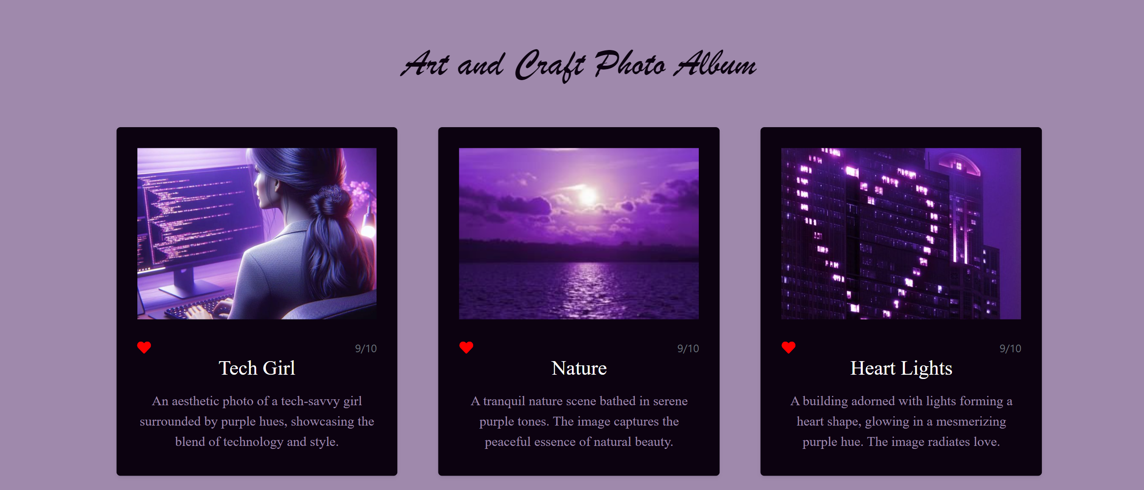

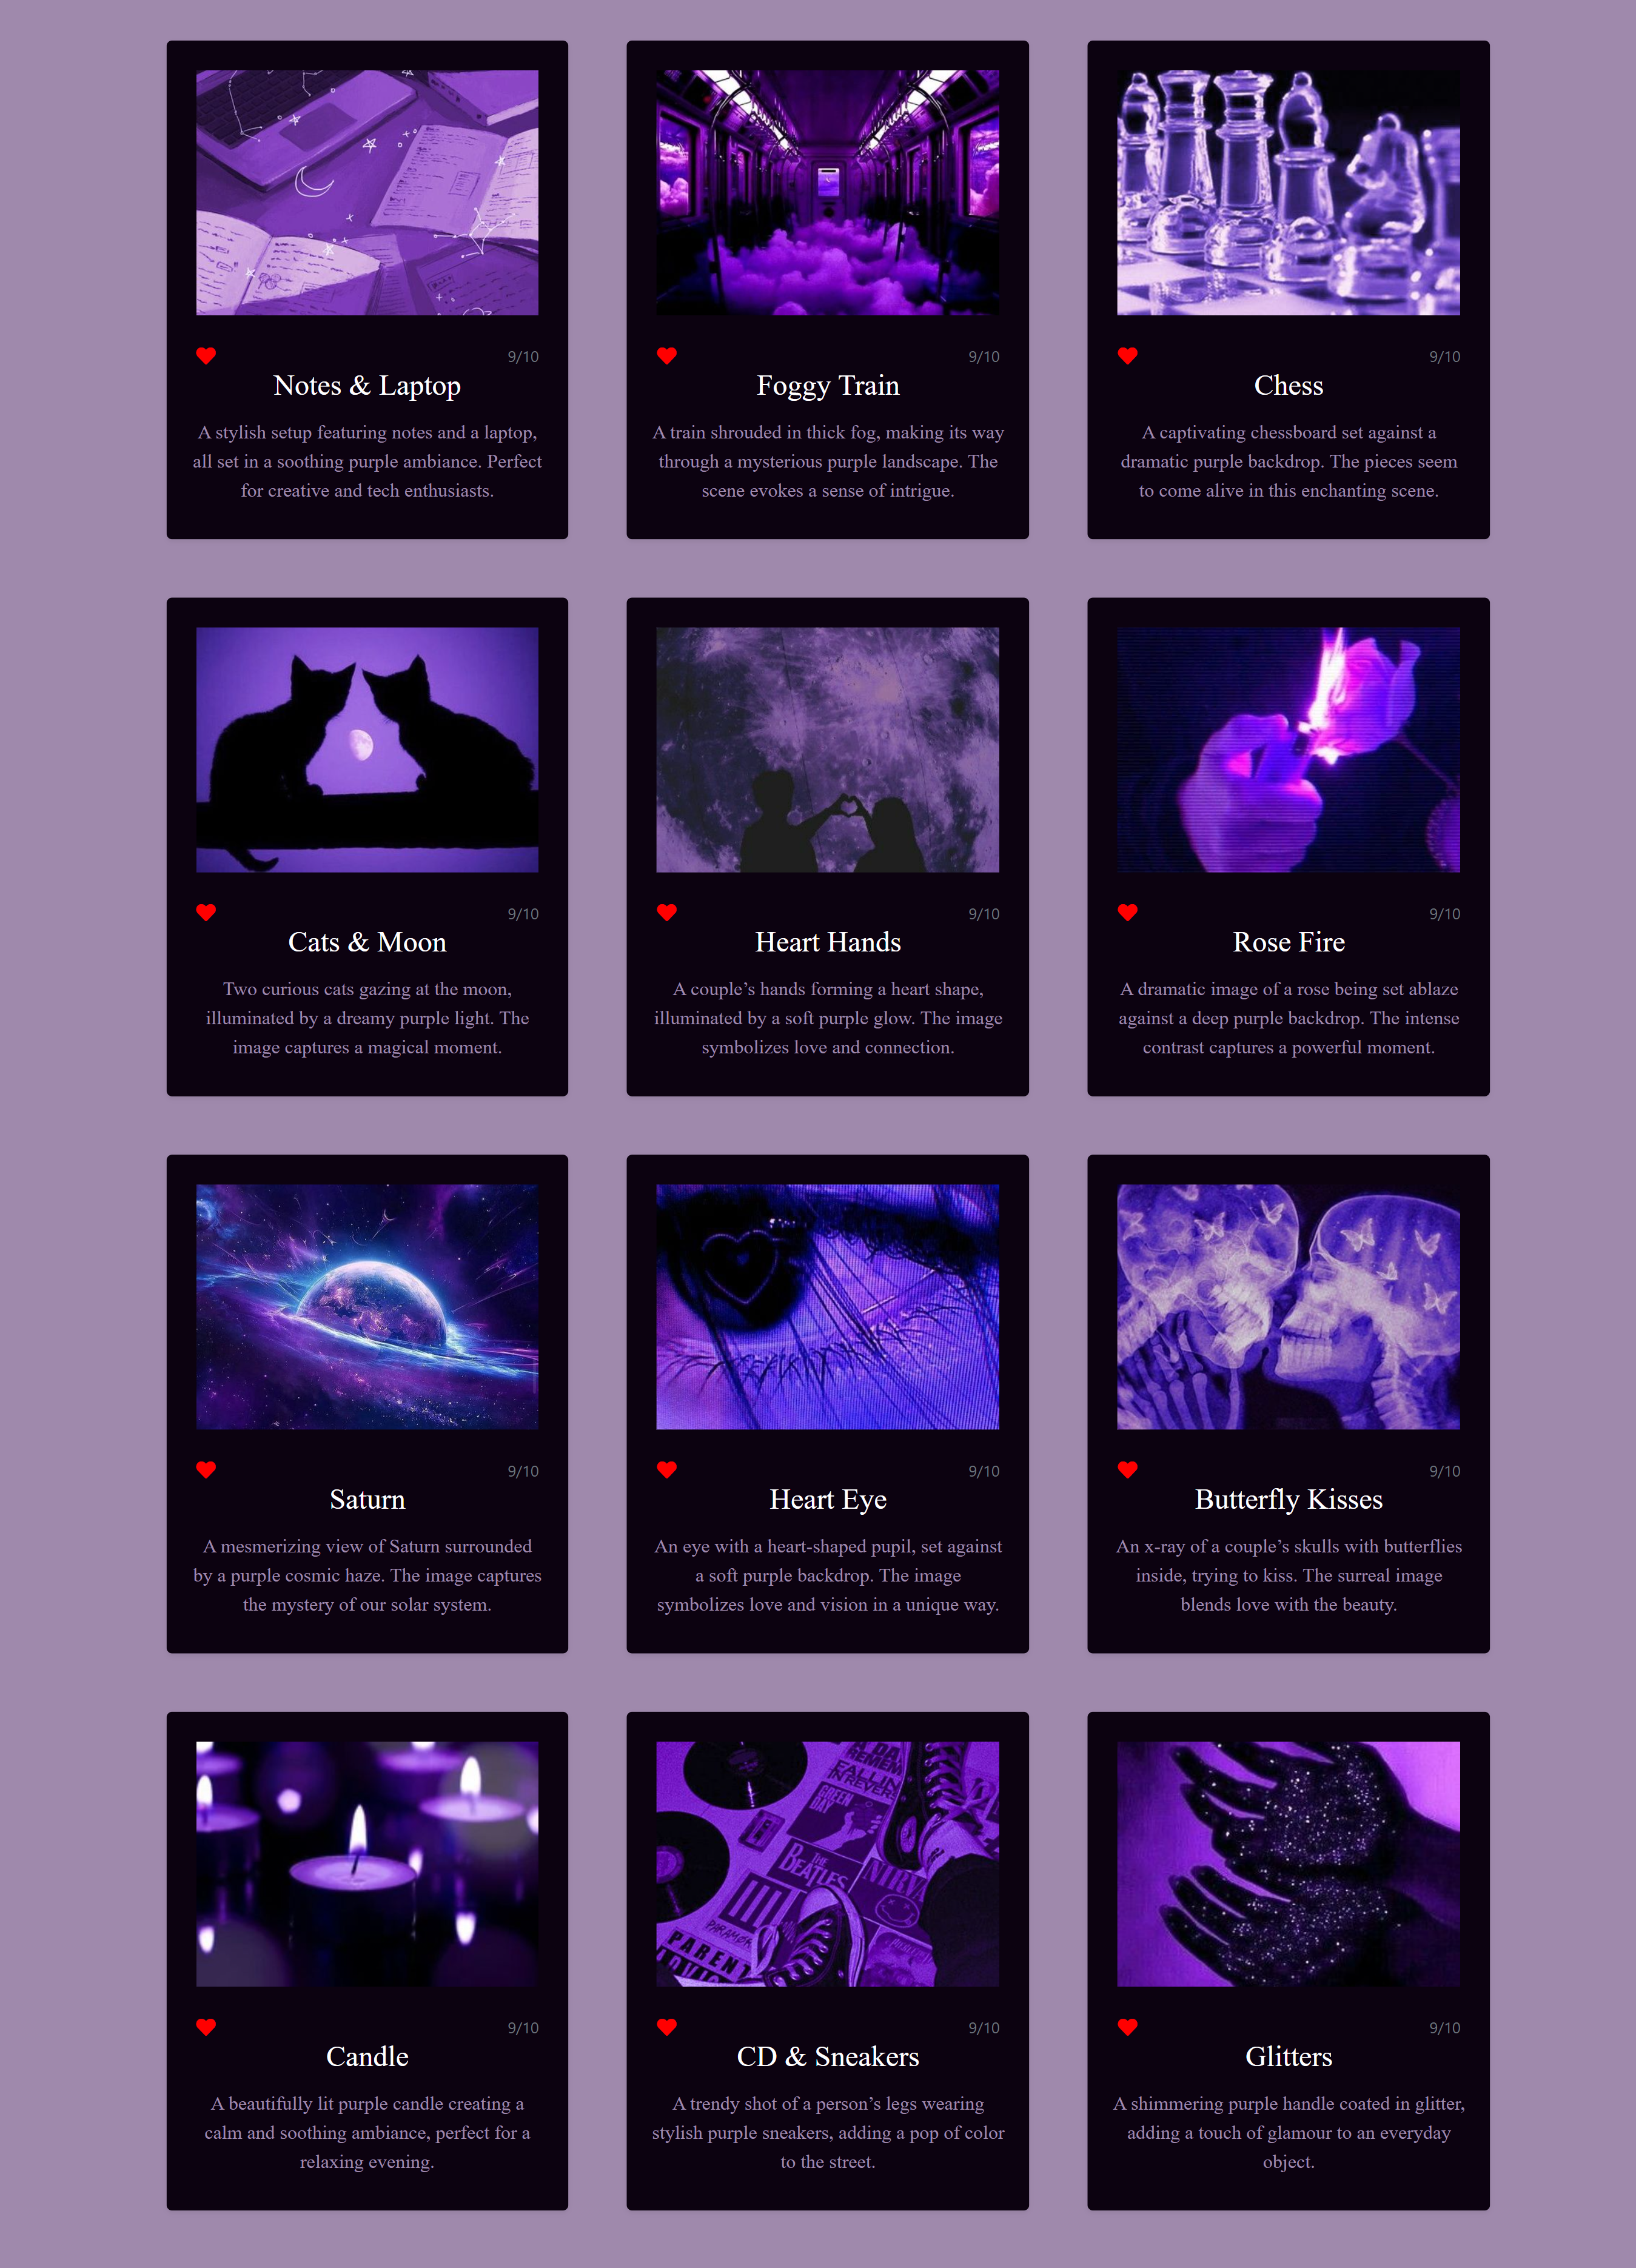

1. Create student marksheet using bootstrap.

Html File :-

<!DOCTYPE *html*>

<html *lang*="en">

  <head>

    <meta *charset*="UTF-8" />

    <meta *name*="viewport" *content*="width=device-width, initial-scale=1.0" />

    <title>Marksheet</title>

    <link

*href*="https://stackpath.bootstrapcdn.com/bootstrap/4.5.2/css/bootstrap.min.css"

*rel*="stylesheet"

    />

    <style>

      body {

        background-color: #f5f5f5;

        font-family: Arial, sans-serif;

      }

*.marksheet-container* {

        background-color: white;

        padding: 20px;

        border: 1px solid #ccc;

        border-radius: 8px;

        max-width: 800px;

        margin: 50px auto;

      }

*.marksheet-header* {

        text-align: center;

      }

*.marksheet-table* {

        margin-top: 20px;

        width: 100%;

      }

*.marksheet-table* th,

*.marksheet-table* td {

        border: 1px solid #ddd;

        padding: 8px;

      }

*.marksheet-table* th {

        background-color: #f2f2f2;

        text-align: center;

      }

*.marksheet-footer* {

        margin-top: 30px;

      }

    </style>

  </head>

  <body>

    <div *class*="marksheet-container">

      <div *class*="marksheet-header">

        <h3 *class*="text-uppercase mb-3">

          Gujarat Secondary and Higher Secondary Education Board

        </h3>

        <h5>MARKS STATEMENT</h5>

        <p>S.No. SSCE / 2020</p>

      </div>

      <div *class*="row">

        <div *class*="col-md-6">

          <p><strong>Name:</strong> Patel Khushi Sanjivbhai</p>

          <p><strong>Mother's Name:</strong> Patel Nita Sanjivbhai</p>

        </div>

        <div *class*="col-md-6">

          <p><strong>Roll No:</strong> 5864147</p>

          <p><strong>Father's Name:</strong> Patel Sanjiv Shankerlal</p>

        </div>

        <div *class*="col-md-12">

          <p *class*="text-uppercase">

            <strong>School:</strong> parth school of science and competition

          </p>

        </div>

      </div>

      <table *class*="table marksheet-table">

        <thead>

          <tr>

            <th>SUB. CODE</th>

            <th>SUBJECT</th>

            <th>TH</th>

            <th>PR</th>

            <th>TOTAL</th>

            <th>TOTAL IN WORDS</th>

            <th>POS. GRADE</th>

          </tr>

        </thead>

        <tbody>

          <tr>

            <td>301</td>

            <td>MATHEMATICS</td>

            <td>097</td>

            <td>XXX</td>

            <td>097</td>

            <td>NINTY SEVEN</td>

            <td>A2</td>

          </tr>

          <tr>

            <td>030</td>

            <td>PHYSICS</td>

            <td>089</td>

            <td>XXX</td>

            <td>089</td>

            <td>EIGHTY NINE</td>

            <td>A1</td>

          </tr>

          <tr>

            <td>048</td>

            <td>CHEMISTRY</td>

            <td>089</td>

            <td>030</td>

            <td>089</td>

            <td>EIGHTY NINE</td>

            <td>A1</td>

          </tr>

          <tr>

            <td>054</td>

            <td>COMPUTER</td>

            <td>074</td>

            <td>010</td>

            <td>074</td>

            <td>SEVENTY FOUR</td>

            <td>B1</td>

          </tr>

          <tr>

            <td>055</td>

            <td>ENGLISH</td>

            <td>081</td>

            <td>020</td>

            <td>081</td>

            <td>EIGHTY ONE</td>

            <td>B2</td>

          </tr>

          <tr>

            <td>500</td>

            <td>PHYSICS PRACTICAL</td>

            <td *colspan*="4"></td>

            <td>A1</td>

          </tr>

          <tr>

            <td>502</td>

            <td>CHEMISTRY PRACTICAL</td>

            <td *colspan*="4"></td>

            <td>A1</td>

          </tr>

          <tr>

            <td>503</td>

            <td>COMPUTER PRACTICAL</td>

            <td *colspan*="4"></td>

            <td>A2</td>

          </tr>

        </tbody>

      </table>

      <p *style*="float: right"><strong>Dated:</strong> 13-04-2020</p>

      <div *class*="marksheet-footer mt-0">

        <p><strong>Result:</strong> PASS</p>

        <p><strong>GRADE:</strong> A1</p>

      </div>

    </div>

  </body>

</html>

